**Android Recipe Maker**

**Design Document**

**Version 1.0**



**Group Id: F1902EA25F**

**Supervisor Name: Muhammad Imran Afzal**

**Revision History**

|  |  |  |  |
| --- | --- | --- | --- |
| **Date (dd/mm/yyyy)** | **Version** | **Description** | **Author** |
| 20/01/2020 | 1.0 | If you are a Cooking Lover but often face situations when you want to make something. Don't be afraid, we have a best recipe maker app which will do that job for you; just start playing around with cooking food at home. | BC160401604  BC160403081 |
|  |  |  |  |
|  |  |  |  |
|  |  |  |  |

**Table of Contents**

1. Introduction of Design Document
2. Entity Relationship Diagram (ERD)
3. Sequence Diagrams
4. Architecture Design Diagram
5. Class Diagram
6. Database Design
7. Interface Design
8. Test Cases

1. Introduction of Design Document

When partnering with a company during the launch or updating of their application, the process can be expedited if the company utilizes a Solution Design Document (SDD) from a tracking implementation standpoint. An effective SDD should contain all of the parameters being considered within the report suite. It does not have to be complicated to be useful; in fact, if the model is more simplistic, there will be fewer opportunities for error or miscommunication. There is an example provide more detail about what should be displayed when the search request is sent, when an event should be fired. If not found then what should be displayed to user. The beauty of this Solution Design Document is that it allows all parameters to be displayed together at once. Mapping out tracking for site changes. Everyone involved in tracking the application will know which props are able to be used for future tracking outlines what will be measured/tracked on the site. Can be utilized by the team that configures the code for tracking. Reduce ramp up time on establishment of new tracking for new members of the team. Can easily display information about a specific “evar,” “soup,” or event. All of the information is stored within one central document.

1. Entity Relationship Diagram (ERD) (To be developed using Microsoft Visio or any other drawing software of your choice)

Admin/User

Register

Ingredients

Search

User

D

Browse

Recipe

(Fig. 01 Entity Relationship Diagram)

1. Sequence Diagrams (To be developed using Rational Rose or any other drawing software of your choice)

User/Admin

Notification

Share

Favorite

Login

Register

Dashboard

Search

Detail

Register

Alt

Show Detail

if user registered

Login

By Ingredients

if found

Alt

Else

Plz register yourself to login

Latest 25

Show Detail

Voice Input

Share Recipe

Mark Favorite

no found

Else

No Recipe found

New Recipe Added

(Fig. 02 Sequence Diagram)

1. Architecture Design Diagram

Main Activity

View Model

Repository

Remote Data Source

Model

Use firebase

To display

Recipe

Manage local

Data for making Favorite

Recipe

Firebase

SQ Lite

(Fig. 03 Architecture Diagram)

1. **Class Diagram**

Username: String

Email: String

Password: String

Confirm Password: String

**Register**

**Login**

Email: String

Password: String

**Login Action**

**Show Detail**

**View Recipe**

**Voice Search**

Voice Search ( )

**Search Recipe**

Show All Recipe ( )

Ingredients: String

Search by ingredient ( )

Title: String

Ingredients: String

Instructions: String

Show Detail ( )

**Share**

**Mark Favorite**

Mark Favorite ( )

Share Recipe ( )

(Fig. 04 Class Diagram)

1. Database Design

Recipe Table

**Database**

(RecipeDB.db)

**Data Model Class**

(Recipe Class)

Activity Class

**Data Handler Class**

(MyDBHandler Class)

(Fig. 05 Database Design)

1. Interface Design

User interface For User

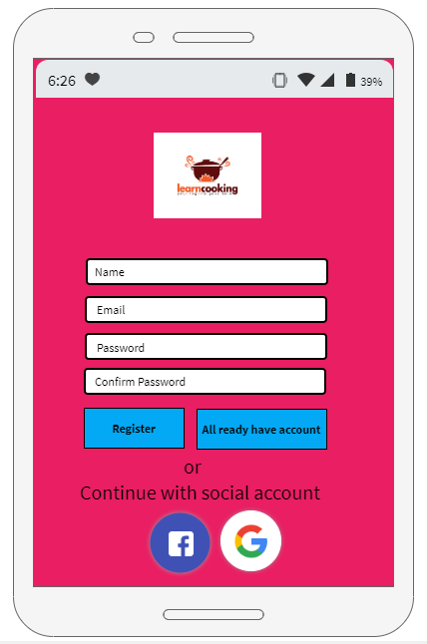

Login User

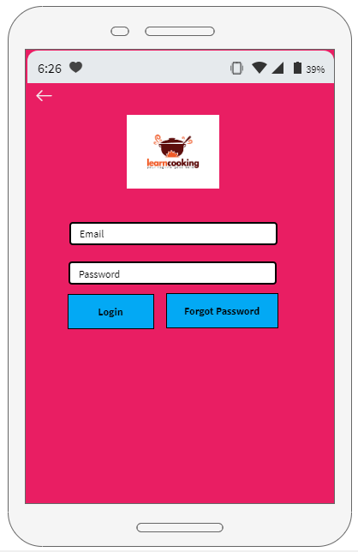

Show 25 Recipe on Home Screen

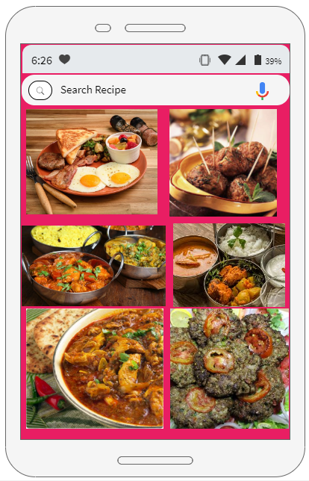

Touch on Each image to show Recipe Name, Detail and Instructions

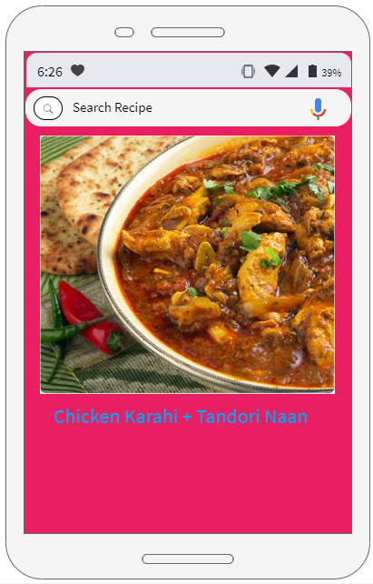

1. **Test Cases**

**Test Case 1:**

|  |  |
| --- | --- |
| **Test Case Title** | Register User |
| **Action** | Admin/Users |
| **Description** | User and admin will be able to register him/her through Facebook/Gmail account or using our app sign up functionality to view the recipes. |
| **Alternative Paths** | If some information is incorrect in records so user can update record for that do all steps again |
| **Pre-Conditions** | The use case begins when the actor type his/her name password on the sign up form |
| **Post conditions** | The user entered successful information and is returned to the home page as a Logged In User |
| **Author** | Saood Ul Hansian, Zaid Ahmad. |
| **Exceptions** | Server not respond or data format is not according to Db format. |

* **Test Case 2:**

|  |  |
| --- | --- |
| **Test Case Title** | Login |
| **Action** | Admin/User |
| **Description** | User will be able to login him/ herself. |
| **Alternative Paths** | If input is invalid, so user will provide it again. |
| **Pre-Conditions** | User register himself and input data correctly according to format in DB. |
| **Post conditions** | User should be able to see/search the recipes.. |
| **Author** | Saood Ul Hansian, Zaid Ahmad. |
| **Exceptions** | Login information incorrect or server not respond. |

**Use Case 3:**

|  |  |
| --- | --- |
| **Test Case Title** | Logout |
| **Action** | Admin/Users |
| **Description** | Users and admin logout form our app. |
| **Alternative Paths** | No alternate step. |
| **Pre-Conditions** | Logout options should be available on side drawer. |
| **Post conditions** | User should be logout from the app. |
| **Author** | Saood Ul Hansian, Zaid Ahmad. |
| **Exceptions** | Server not respond if the internet connection is down. |

**Test Case 4:**

|  |  |
| --- | --- |
| **Test Case Title** | View Top Recipes |
| **Action** | Admin/Users |
| **Description** | Users/Admin can see top 25 recipes of our App |
| **Alternative Paths** | No alternate step. |
| **Pre-Conditions** | User should be login and on home Screen. |
| **Post conditions** | On select recipe user will be able to view the ingredients, share on social media, directions and mark favourite. |
| **Author** | Saood Ul Hansian, Zaid Ahmad. |
| **Exceptions** | Server not respond if the internet connection is down. |

**Test Case 5:**

|  |  |
| --- | --- |
| **Test Case Title** | Input Voice Method |
| **Actors** | Admin/Users |
| **Description** | User can provide multiple ingredients by typing via on-screen keyboard and user can use voice for input and application will convert audio into text using Voice Recognition technology, provided by Google. |
| **Alternative Paths** | At the right corner of search bar there will be input for voice icon |
| **Pre-Conditions** | By typing |
| **Post conditions** | Application will convert audio into text using Voice Recognition technology, provided by Google and produces result if condition meets. |
| **Author** | Saood Ul Hansian, Zaid Ahmad. |
| **Exceptions** | Server not respond if the internet connection is down. |

**Test Case 6:**

|  |  |
| --- | --- |
| **Test Case Title** | Manage Users |
| **Action** | Admin |
| **Description** | Admin will be able to create new recipes ,delete recipes ,edit recipes |
| **Alternative Paths** | No |
| **Pre-Conditions** | On selecting recipe item there should be edit ,delete option and on Side drawer should be add new recipe option. |
| **Post conditions** | Upon editing ,deleting and create new recipe our db should be updated. |
| **Author** | Saood Ul Hansian, Zaid Ahmad. |
| **Exceptions** | Server not respond if the internet connection is down. |

**Test Case 7:**

|  |  |
| --- | --- |
| **Test Case Title** | My Cook Book |
| **Action** | Admin/User |
| **Description** | The user is given choice to create personal cookbook, where user can view recipe and delete recipe |
| **Alternative Paths** | No |
| **Pre-Conditions** | There should be heart like item on the below right corner of item. |
| **Post conditions** | Upon tapping heart icon that recipe item should be added to favorites. |
| **Author** | Saood Ul Hansian, Zaid Ahmad. |
| **Exceptions** | Server not respond if the internet connection is down. |

**Test Case 8:**

|  |  |
| --- | --- |
| **Test Case Title** | Share on social media |
| **Action** | Admin/User |
| **Description** | Upon selecting recipe item at top right corner there should be share recipe icon |
| **Alternative Paths** | No |
| **Pre-Conditions** | There should be heart like item on the below right corner of item. |
| **Post conditions** | Upon tap on share there will be popup bottom bar option share on Facebook ,Gmail etc and after selecting sharing media application will create link message. |
| **Author** | Saood Ul Hansian, Zaid Ahmad. |
| **Exceptions** | Server not respond if the internet connection is down. |